February 9, 2020

Welcome! We are delighted that you have come to worship with us. During the worship time this morning we will commission the Guatemala Mission Team. Please keep the team in prayer as they will be leaving this week. Everyone is invited to join us for a time of fellowship after the morning service.

9:30 A.M. WORSHIP SERVICE
Prelude: “O Worship the King”

Welcome & Announcements

*Call to Worship
*Opening Song: “Here I Am to Worship”

*God's Greeting
*Mutual Greeting

Commissioning of the Guatemala Mission Team
Offering: General Fund / Faith Promise
Offertory: “Reckless Love” Tyler Burt

Prayer

Song of Preparation: “Open the Eyes of My Heart”
Children’s Message
Scripture Passage: Revelation 5
Message: “A Vision for Mission”
Prayer of Application
*Song: “There is a Redeemer”

*Commissioning
*Song: “As You Go on Your Way”
*Moment of Meditation
*Postlude: “Agnus Dei”

*Indicates Standing

ASSIGNMENTS

Greeting us today: The Elders
Next Sunday: Randy & Kathy Frens

Caring for our children this morning – Kristin Brookhouse, Linda
Rought, Samantha Bennett
Feb. 16 – Paula DeLong, Stephanie Burton, Katelynne
Gerth
Feb. 23 – Colleen Rottier, Lauri Buter, Kaitlynn Bennett

Children in Worship today: Cheryl Kraley, Blake & Max Taylor
Next Sunday: Tricia Sparks, Mason & Ellen

Fellowship time: Scott Breuker & Jared Krick
Feb. 16 – Mark Perysian & Duane Luchies
Feb. 23 – Stan Witte & Jim Bazzett

Ushers today: Ron Breuker & Jared Krick
Next Sunday: Dan Folkema & Jared Krick

ANNOUNCEMENTS

ǂ GEMS will meet Wednesday, 6:30 – 7:45 p.m.

ǂ Baked Goods are needed for Wellspring snacks. If you have any questions, contact Tammy Cowley.

ǂ A memorial service for Gay Geerlings will be held tomorrow evening, February 10th, 6 p.m., at Reeman Church. A time of food and fellowship will be held in the fellowship hall following the service.

ǂ Items Needed: About a week ago Mike, Monica and Evelyn Burt had a fire at their home that damaged the majority of their possessions. Thankfully everyone was safe, but they are in need of help replacing some of the things they lost in the fire. There is a list of items needed at the welcome center if you would be willing to help them during this difficult time. All items can be turned in to the box at the welcome center. If you have any questions, please talk with Patti Van Dyke or Sherry Lubbers.
Please have all items brought to church by next Sunday, February 16. Thank you.

ǂ Giving envelopes - If you would like a record of your giving, envelopes are available. Contact Tyler Burt or Marcia Lubbers.

ǂ Prayers are requested for the Guatemala Team. They will be leaving this Wednesday at 11 p.m. You can follow them on Facebook at Reeman Guatemala Team 2020.

ǂ You are invited to start the season of Lent with an Ash Wednesday worship at 6:30 pm at First Fremont CRC on February 26. Our worship time will include times of prayer, singing, scripture reading and reflection as well as imposition of ashes.

ǂ B&B Marriage Retreat! The Parsonage Inn in Grand Rapids is hosting a marriage retreat this Feb 28 - Mar 1, Friday night through Sunday morning. Pastors Steven and Deb Koster will lead seasoned couples and newlyweds alike through a series of talks bookended by two relaxing evenings in their Victorian B&B (at 423 Madison Ave SE, GR, 45903). The registration fees include two nights at the B&B, the seminars, breakfasts, and a Saturday picnic lunch. For more information email info@ParsonageInn.org, call 616-481-4434, or visit ParsonageInn.org online.

ǂ Singer/songwriter Jason Gray will be returning to Fremont to share Worship, and personal songs and stories through music. On Sunday evening, February 9, at 6 pm, you are invited to First Fremont Christian Reformed Church for this event. Jason will allow music requests and there will be a fellowship time following the worship event. If you desire, you will also be able to meet and greet with Jason. All of this for FREE. A Love Offering will be taken to help offset the costs of the event and to support the CureUs Ministry-a Newaygo County Non-profit Ministry. If you have questions, please call the First Fremont CRC office at 231.924.2460. For more information, please visit https://www.eventbrite.com/e/worship-and-fellowship-with-singersongwriter-jason-gray-tickets-86815827477?aff=ebdssbdestsearch.

Reeman Christian Reformed Church

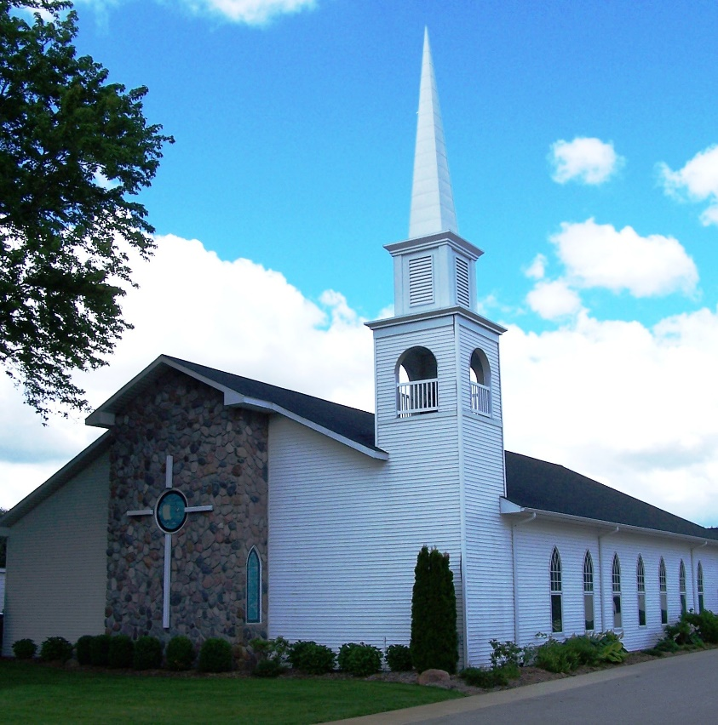

As a part of God’s family
We strive to show Christ’s love to all
For the glory of God

Pastor Les Van Dyke
Pastor Nate Kooistra

