June 13, 2021

Welcome! We are glad that you are here to worship the Lord!
Today is the second message in the sermon series called, “Life’s Landscapes – Navigating Spiritual Geography.”

In this series we will journey to various landscapes in Scripture and see how these relate to our spiritual lives. We will the tour the garden, travel to the wilderness, climb mountains, hike through valleys, cross rivers and lakes, and more. Be sure to travel with us this summer as we explore various landscapes of scripture and the ways they shape our lives.

9:30 A.M. Worship Service

Prelude
Welcome and Announcements

Call To Worship
*Opening Song: “Come, Thou Fount of Every Blessing”
*God’s Greeting

Confession and Renewal
Congregational Prayer

*Song: “Spirit of the Living God”
(Children Ages 2-Kindergarten are dismissed for Children’s Worship)

Scripture: Ezekiel 47
Sermon: “Take Me To The River”
Prayer

*Song of Response: “Like a River Glorious”
*Departing Blessing
*Song: “Praise God, from Whom All Blessings Flow”
*Moment of Meditation
*Postlude

* Indicates standing

ANNOUNCEMENTS

Children in Worship today: Tara Johnson &
Natalee Tyink
Next Sunday: Tara Johnson & Sydney Moon

Nursery Attendants today: Sue Tibbe & Alicia Schafer
June 20 – Rebecca Krick & Molly Kooistra
June 27 – Bethany Hooker & Samantha Greer
July 4 – Elizabeth Wolffis & Helen Bowyer

Praise Team will practice Wednesday evening at 6:30 p.m.

Council will meet Thursday, June 17, at 7 p.m.

High Schoolers! Thanks for a fun year! Even though regular FYSH events are over, please look forward to these upcoming events:
- June 30th a fun evening planned!
- July 18 - FYSH Whitecaps @ 6 pm
- August 14 or 21 - (Possible Day on the Lake)
We are in need of help for funeral luncheons, either working at them or baking cakes, cookies or brownies. If you are willing to help, please sign the sheet at the Welcome Center.

We are going to start with “coffee” after the church service soon. If you would be willing to take a turn, please sign up at the Welcome Center. Those who were on the list previously will remain on the list unless they ask to have their name removed.

Father’s Day is the perfect day to honor those who gave us the gift of life. If you would like to thank your Father, Grandfather or any special man for choosing life and nurturing you, place their name on the list at the welcome center and enclose $2.00 for each name. Indicate the living under in Honor Of and those who have passed on under in Memory Of. The names will be printed in the Hi-Lites on Father’s Day by Newaygo County Right to Life. Every life is precious and designed by God.

Elevate Sports Camp is designed for kids entering grades 3-8 and covers a variety of sports. In our first year (2019), we included basketball, volleyball, soccer and baseball/softball. This year we're offering track and field instead of baseball. Using local coaches, participants learn basic skills and drills and then have an opportunity to engage in some competition using those new or refined skills. We also include a faith component and challenge participants with a short Bible lesson and small group time. Registration is open at https://www.firstcrcfremont.org/sports-camp or call the church office for more information (231) 924-2460.

Insight Pregnancy Services (1007 W. Main, Fremont) is hosting a Program of Dedication celebrating the limited ultrasound services in their new medical clinic. You are invited to join them today, 11 a.m. – 2 p.m. or Monday, June 14, 8 a.m. – 10 a.m. Light refreshments will be served on both dates.

Reeman Christian Reformed Church

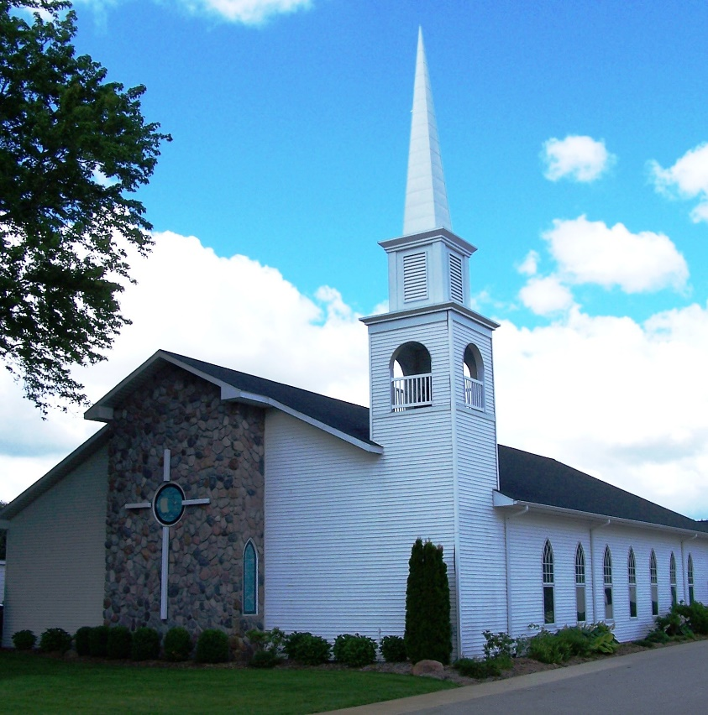

As a part of God’s family
We strive to show Christ’s love to all
For the glory of God

Pastor Les Van Dyke
Pastor Nate Kooistra

