9:30 A.M. Worship Service

Prelude
Welcome and Announcements
*Call To Worship:
*Opening Song: “God Himself Is with Us.”

*God’s Greeting
*Mutual Greeting

Testimony of Faith: Heidelberg Catechism Q&A 117
Q. How does God want us to pray so that he will
listen to us?

A. First, we must pray from the heart
to no other than the one true God,
who has revealed himself in his Word,
asking for everything he has commanded us to
ask for.

Second, we must acknowledge our need and
misery, hiding nothing,
and humble ourselves in his majestic presence.

Third, we must rest on this unshakable
foundation:
even though we do not deserve it,
God will surely listen to our prayer
because of Christ our Lord.
That is what he promised in his Word.

Congregational Prayer
Offering: General Fund/Faith Promise

*Song: “Open Our Eyes, Lord”
Children's Message
Prayer Of Illumination
Scripture: Matthew 7:1-12
Sermon: “Don’t Point. Pray!”
Prayer

*Song of Response: “What a Friend We Have in Jesus”
*Departing Blessing
*Song: “Seek Ye First”
*Moment of Meditation
*Postlude
* Indicates Standing

ASSIGNMENTS

Greeting us today: Randy & Kathy Frens
Next Sunday: Cadets

Caring for our children this morning Paula DeLong, Stephanie
Burton, Katelynne Gerth
Feb. 23 – Colleen Rottier, Lauri Buter, Kaitlynn Bennett
Mar. 1 – Katie Mater, Sue Tibbe, Sydney Moon
Mar. 8 – Samantha Greer, Leslie Bennett, Emma Krick

Children in Worship today: Tricia Sparks, Mason & Ellen
Next Sunday: Tricia Sparks, Mason & Ellen

Fellowship time: Mark Perysian & Duane Luchies
Feb. 23 – Stan Witte & Jim Bazzett
Mar. 1 – Jeff Clark & Rich DeLong
Mar. 8 – Nate Sparks & Geneva Thomas

Ushers today: Dan Folkema & Jared Krick
Next Sunday: Jeff Clark & Jared Krick

ANNOUNCEMENTS

ǂ GEMS will meet Wednesday, 6:30 – 7:45 p.m.

ǂ Baked Goods are needed for Wellspring snacks. If you have any questions, contact Tammy Cowley.

ǂ Next Sunday is “Cadet Sunday” and a special offering will be taken for the Cadet Corps.

ǂ A big THANK YOU to all who have given items to Mike and Monica. Please be sure that all items are here at church today as we will be delivering them this week.

ǂ Giving envelopes - If you would like a record of your giving, envelopes are available. Contact Tyler Burt or Marcia Lubbers.

ǂ Prayers are requested for the Guatemala Team. You can follow them on Facebook at Reeman Guatemala Team 2020.

ǂ You are invited to start the season of Lent with an Ash Wednesday worship at 6:30 pm at First Fremont CRC on February 26. Our worship time will include times of prayer, singing, scripture reading and reflection as well as imposition of ashes.

ǂ Men's Lenten Breakfast will begin on February 28, 7 a.m. at the Church of the Living Christ.

ǂ B&B Marriage Retreat! The Parsonage Inn in Grand Rapids is hosting a marriage retreat this Feb 28 - Mar 1, Friday night through Sunday morning. Pastors Steven and Deb Koster will lead seasoned couples and newlyweds alike through a series of talks bookended by two relaxing evenings in their Victorian B&B (at 423 Madison Ave SE, GR, 45903). The registration fees include two nights at the B&B, the seminars, breakfasts, and a Saturday picnic lunch. For more information email info@ParsonageInn.org, call 616-481-4434, or visit ParsonageInn.org online.

Reeman Christian Reformed Church

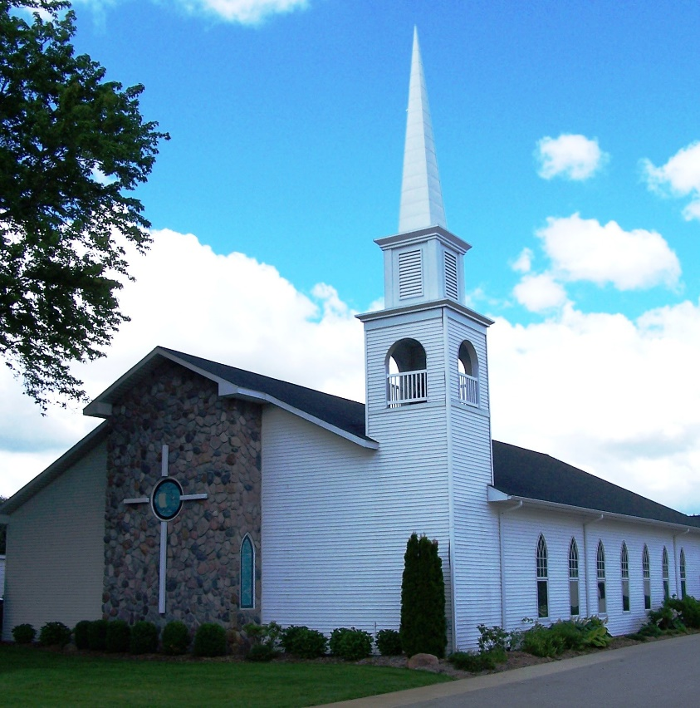

As a part of God’s family
We strive to show Christ’s love to all
For the glory of God

Pastor Les Van Dyke
Pastor Nate Kooistra

GRIEFSHARE INFORMATION

ǂ Loss of a spouse – On Tuesday, February 25, First Fremont CRC is offering a 2-hour seminar from 6:30 – 8:30 p.m. There will be a 35-minute video followed by small group discussion. The video features expert Christian counselors, authors, and pastors, including interviews with some men and women who have experienced grief. Through the seminar you will discover: that other people understand and have found ways to make it through; why it won’t always hurt so much; reasons for hope; and practical tips for coping with the death of a spouse.
Participants take home a valuable “Loss of a Spouse” booklet that includes: 1.) a video-taking outline, 2.) devotional materials that help people find hope in God’s word and eventually rebuild your life, 3.) grief recovery exercises, and 4.) journaling prompts.
There is a $5.00 charge, scholarships are available, and it is helpful, but not mandatory, to register at the church office – 231/924-2460. Any questions, call or check online at www.griefshare.org.

ǂ Griefshare – We would like to welcome any adult who has lost a loved one to attend a GriefShare Group. This non-denominational 13-week course offers help and support for the grieving. Each class is special and different, focusing on a DVD featuring grief experts and real-life stories. A $10 fee is for your personal workbook, which you will use in the program to help and guide you in your healing. Sessions will be on consecutive Tuesdays beginning March 3, from 6:30 – 8:30 p.m. Registration with our church (231/924-2460) is helpful for planning but is not required. This is an excellent program to help you on your journey from mourning to joy! Additional information at www.griefshare.org. We look forward to meeting you at First CRC and walking with you on your journey through this difficult time. God Bless You!

