9:30 A.M. WORSHIP SERVICE

Prelude
Welcome and Announcements
*Call To Worship: Psalm 96:10-13
*Opening Song: “Unto God Our Savior”

*God’s Greeting
*Mutual Greeting

Song of Confession: “God, Be Merciful to Me”

Congregational Prayer
Offering: General Fund

*Song: “Lord, Listen to Your Children Praying”
Children's Message
Prayer Of Illumination
Scripture: Matthew 7:1-12
Sermon: “Poor Judgment”
Prayer

*Song of Response: “Rock of Ages”
*Departing Blessing
*Song: “Doxology”
*Moment of Meditation
*Postlude

* Indicates Standing

ASSIGNMENTS

Greeting us today: Chad & Sara Heykoop
Next Sunday: The Elders

Caring for our children this morning – Sara Heykoop, Becky
Stroven, Molly Kooistra
Next Sunday: Kristin Brookhouse, Linda Rought,
Samantha Bennett
Feb. 16 – Paula DeLong, Stephanie Burton, Katelynne
Gerth
Feb. 23 – Colleen Rottier, Lauri Buter, Kaitlynn Bennett

Children in Worship today: Cheryl Kraley, Blake & Max Taylor
Next Sunday: Cheryl Kraley, Blake & Max Taylor

Fellowship time: Luke Van Dop & Casey Sparks
Feb. 9 – Scott Breuker & Jared Krick
Feb. 16 – Mark Perysian & Duane Luchies
Feb. 23 – Stan Witte & Jim Bazzett

Ushers today: Larry Chrystler & Jared Krick
Next Sunday: Ron Breuker & Jared Krick

ANNOUNCEMENTS

ǂ GEMS will meet Wednesday, 6:30 – 7:45 p.m.

ǂ Pastor Les will be on vacation January 27 – February 3. Please contact Pastor Nate if you have any pastoral needs.

ǂ Council will meet Thursday, February 6^{th,} at 7:00 p.m.

ǂ Items Needed: About a week ago Mike, Monica and Evelyn Burt had a fire at their home that damaged the majority of their possessions. Thankfully everyone was safe, but they are in need of help replacing some of the things they lost in the fire. There is a list of items needed at the welcome center if you would be willing to help them during this difficult time. All items can be turned in to the box at the welcome center. If you have any questions, please talk with Patti Vandyke or Sherry Lubbers.

ǂ Love and Logic Parenting has only two rules...#1 Adults set limits without anger, lectures, threats, or repeated warnings. And #2 When children cause problems, adults hand these problems back in loving ways. Learn the practical ways to implement these rules. This approach gives you new tools for your parenting "tool belt" that are simple and practical.
PARENTING THE LOVE AND LOGIC WAY®
Dates: Feb. 3-Mar. 9, 2020 (six consecutive Monday evenings)
Time: 7-9 p.m.; Place: Fremont Rec Center
Cost: $50 per family. Contact: Sharon Deur sharond.outpost@gmail.com/616.219.4392
Before you decide, check out loveandlogic.com for yourself: It’s been around for 42 years!

ǂ B&B Marriage Retreat! The Parsonage Inn in Grand Rapids is hosting a marriage retreat this Feb 28 - Mar 1, Friday night through Sunday morning. Pastors Steven and Deb Koster will lead seasoned couples and newlyweds alike through a series of talks bookended by two relaxing evenings in their Victorian B&B (at 423 Madison Ave SE, GR, 45903). The registration fees include two nights at the B&B, the seminars, breakfasts, and a Saturday picnic lunch. For more information email info@ParsonageInn.org, call 616-481-4434, or visit ParsonageInn.org online.

ǂ Singer/songwriter Jason Gray will be returning to Fremont to share Worship, and personal songs and stories through music. On Sunday evening, February 9, at 6 pm, you are invited to First Fremont Christian Reformed Church for this event. Jason will allow music requests and there will be a fellowship time following the worship event. If you desire, you will also be able to meet and greet with Jason. All of this for FREE. A Love Offering will be taken to help offset the costs of the event and to support the CureUs Ministry-a Newaygo County Non-profit Ministry. If you have questions, please call the First Fremont CRC office at 231.924.2460. For more information, please visit https://www.eventbrite.com/e/worship-and-fellowship-with-singersongwriter-jason-gray-tickets-86815827477?aff=ebdssbdestsearch.

ǂ Local Mission Leader Opportunity
Resonate Global Mission is hiring an eight hour per week Local Mission Leader to serve the churches in Classis Muskegon. We are looking for a mission-focused, self-motivated, team-player to help the churches of our classis engage their neighborhoods and communities and develop new ministry opportunities. Applications are due January 30, 2020. To see the job description and to apply, visit https://careers-crcna.icims.com/jobs/1332/local-mission-leader---muskegon/job. For more information, contact Amy Schenkel (aschenkel@crcna.org), Nate Visker (nate@ferrysburgchurch.com), or Tara Foreman (tara@bethanychurchmuskegon.org).

Reeman Christian Reformed Church

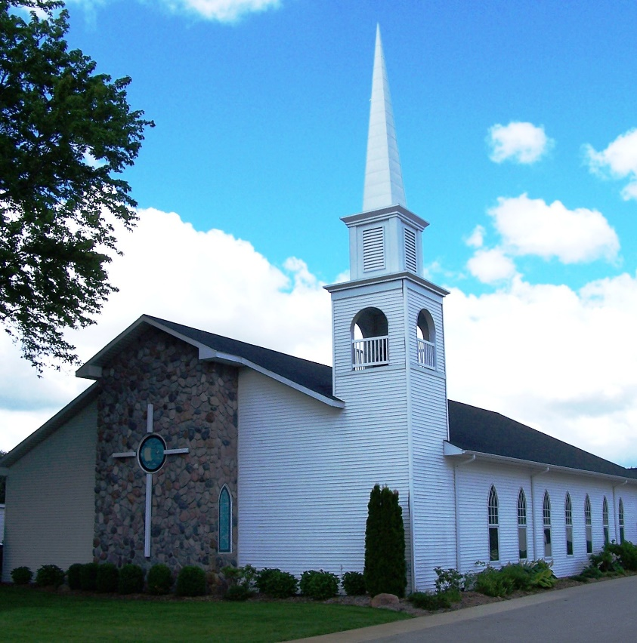

As a part of God’s family
We strive to show Christ’s love to all
For the glory of God

Pastor Les Van Dyke
Pastor Nate Kooistra

